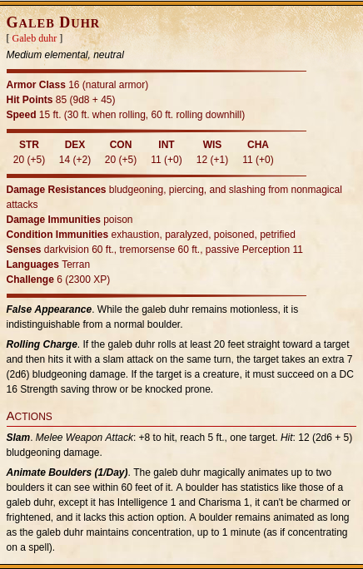
Party will fight two Galeb Duhrs

These Galeb Duhrs’ “Animate Boulders” ability may be used 1/Day as a BA

